 | CUSTOM ORDER GUIDE  Bake-on decals

EXAMPLE TIP SIZE  10mm × 25mm | APPROX. DECAL AREA  ~10mm × 20mm | FINISH  Bake-on, fused at 1150°F | COLOR  2 colors recommended
01 Keep it to 2 colors when possible
Rectangular logos print cleanest, but the constraint here is color count and detail. We recommend keeping it to 2 colors at this scale. Three is technically possible but can introduce registration issues, so it’s best reserved for when it’s truly needed. Each decal is fused to the glass at 1150°F. Photographs, gradients, and 4+ color marks are not feasible at this scale.
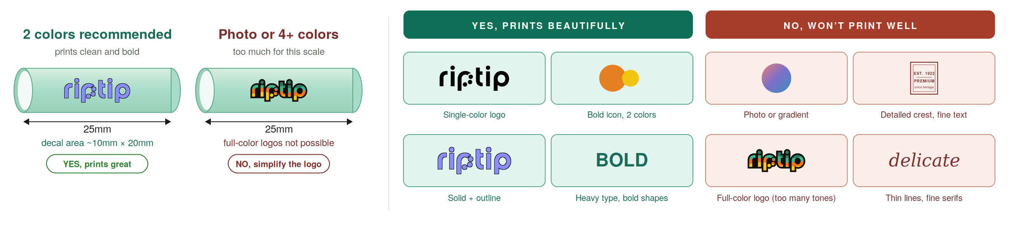
WHAT TO SEND  • Vector files only: .ai, .eps, .svg, or .pdf  • Specify desired colors (we’ll match as close as possible to our glass pigment palette)  • All text converted to outlines  • No JPEG or PNG (rasters can’t print clean) | THREE RULES  • 2 colors recommended, no gradients or photos  • Bold, simple shapes survive at this scale  • Test at actual size: print at 20mm wide | HOW IT WORKS  • Send vector files to info@theriptip.com (Google Drive or Dropbox links also fine for large files)  • Decals work on all tip sizes (7mm to 13mm) and on Clear or Full Color glass  • Production: 60 to 90 days end to end. 100 tip minimum, can be split across sizes

Can I get more than 3 colors?  Not at this scale. The cylinder is too small for clean reproduction beyond 3. | Can you redraw my logo?  No, please send finished vector files ready to print. | Will the decal wear off?  Bake-on decals are very durable, but they can show wear over time.
theriptip.com / info@theriptip.com / Made in USA

