 | CUSTOM ORDER GUIDE  Laser etching

EXAMPLE TIP SIZE  10mm × 25mm | APPROX. ETCH AREA  ~18 × 6mm | FINISH  Frosted matte on clear | COLOR  Frosted look only
01 Logo shape decides everything
RipTips are small and curved. The visible face of a 10mm cylinder is only ~6-7mm wide before the curve takes over. Rectangular logos use the full length and stay sharp. Square and circular logos shrink to fit, and detail disappears.
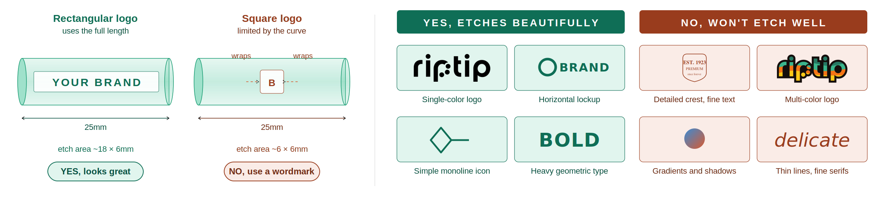
WHAT TO SEND  • Vector files only: .ai, .eps, .svg, or .pdf  • Single color, black on transparent  • All text converted to outlines  • No JPEG or PNG (rasters can’t etch) | THREE RULES  • Strip it down. Drop the tagline and est. date  • Test at actual size: print at 18mm wide  • Bold beats delicate. No lines under 0.5pt | HOW IT WORKS  • Send files to info@theriptip.com  • Best on sizes 10mm to 12mm, where the etch area is largest. We don’t recommend etching on 7mm tips  • Production: 2 to 3 weeks on in-stock tips. 100 tip minimum, can be split across sizes

Can I get my logo in color?  Not with etching. Decals support 2-3 colors. | Can you redraw my logo?  No, please send finished vector files ready to etch. | What if it doesn’t fit?  We’ll flag it before production and ask for alternatives.
theriptip.com / info@theriptip.com / Made in USA

